Daily Biology STAAR Practice Week of  April 3-7, 2017  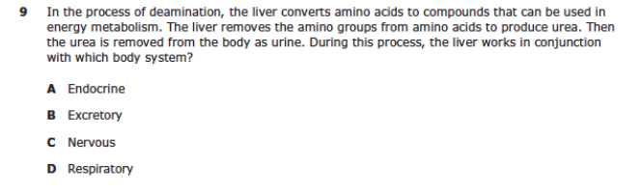  The correct answer is _________ because  _________________________________.  Monday | 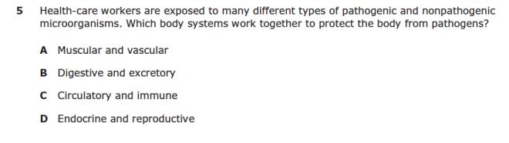The correct answer is _________ because  _________________________________.  Monday | 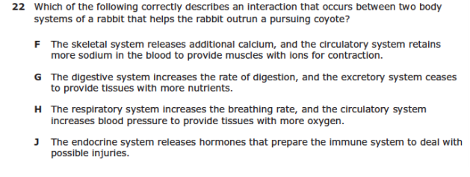  The correct answer is _________ because  _________________________________.  Tuesday
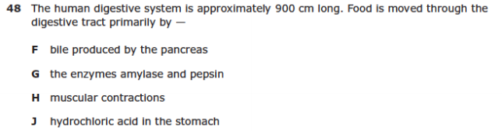  The correct answer is _________ because  _________________________________.  Tuesday | ________________________________________  Name  _________________  Period | 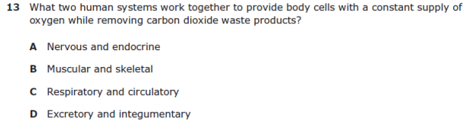  The correct answer is _________ because  _________________________________.  Wednesday

Daily Biology STAAR Practice Week of  March 20-24, 2017  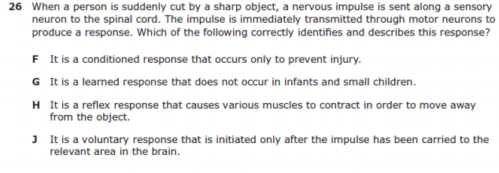  The correct answer is _________ because  _________________________________.  Wednesday | 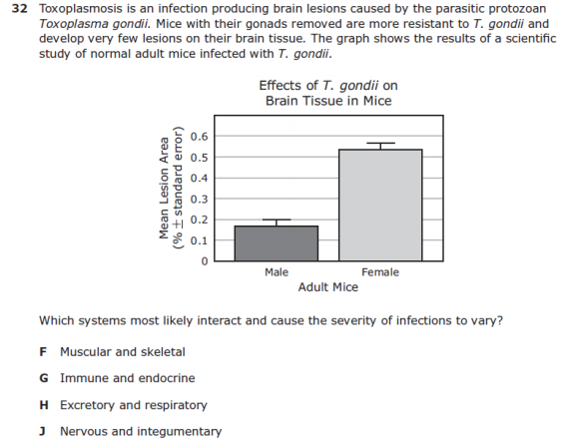  The correct answer is _________ because  _________________________________.  Thursday | 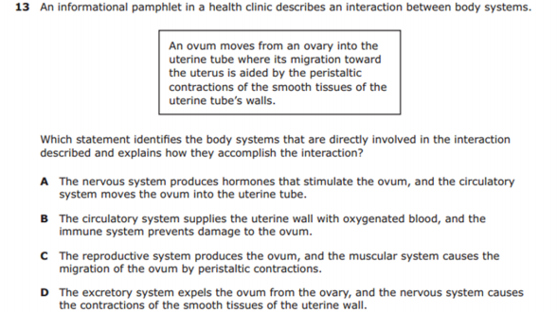  The correct answer is _________ because  _________________________________.  Thursday
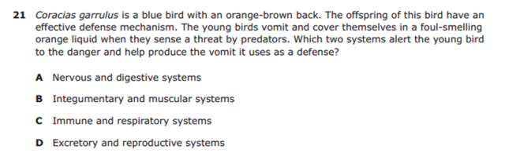  The correct answer is _________ because  _________________________________.  Friday | ________________________________________  Name  _________________  Period | 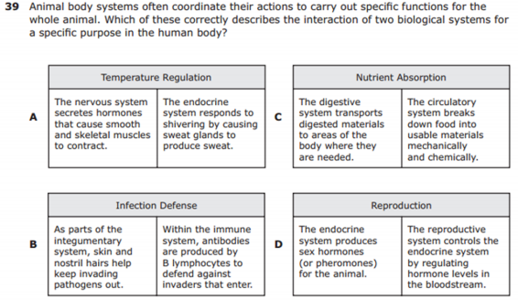  The correct answer is _________ because  _________________________________.  Friday

